**Experiment 4**

**Aim:** To implement Javascript basics

**Theory:**

JavaScript is a lightweight, cross-platform, and interpreted compiled programming language which is also known as the scripting language for web pages. It is well-known for the development of web pages, many non-browser environments also use it. JavaScript can be used for Client-side developments as well as Server-side developments. Javascript is both an imperative and declarative type of language. JavaScript contains a standard library of objects, like Array, Date, and Math, and a core set of language elements like operators, control structures, and statements.

**Code:**

**Html Code:**

<!DOCTYPE html>

<html lang="en">

    <head>

        <meta charset="UTF-8">

        <meta http-equiv="X-UA-Compatible" content="IE=edge">

        <meta name="viewport" content="width=device-width, initial-scale=1.0">

        <title>Document</title>

    </head>

    <body>

        <h2>JavaScript variables</h2>

        <p id="demo"></p>

        <h2>Javascript Function</h2>

        <p id="demo1"></p>

        <h2>Javascript Condition(if..else)</h2>

        <p id="demo2"></p>

        <h2>Javascript loop(for loop)</h2>

        <p id="demo3"></p>

        <h2>JavaScript events</h2>

        <button onclick="document.getElementById('id1').style.color = 'red'">

            Click Me!

        </button>

        <p id="demo4"></p>

        <h2>Javascript DOM CSS</h2>

        <h1 id="id1">My Heading 1</h1>

        <p id="p1">Hello World!</p>

        <p>The paragraph above was changed by a script.</p>

        <p>Please input a number between 1 and 10:</p>

        <input id="num">

        <button type="button" onclick="myFunction()">Submit</button>

        <p id="demo5"></p>

        <script src="first.js"></script>

    </body>

</html>

**Javascript Code:**

var x = 5;

var y = 6;

var z = x + y;

document.getElementById("demo").innerHTML = "The value of z is: " + z;

function myFunction(p1, p2) {

  return p1 * p2;

}

document.getElementById("demo1").innerHTML =   "the value of function multiplication is:" + myFunction(4, 3);

var a = 4;

var b = "";

if (a % 2 == 0) {

  b = "even no";

} else {

  b = "odd no";

}

document.getElementById("demo2").innerHTML = "the number is: " + b;

const cars = ["python", "java", "C", "C++", "HTML", "React"];

let text = "";

for (let i = 0; i < cars.length; i++) {

  text += cars[i] + "<br>";

}

document.getElementById("demo3").innerHTML = text;

document.getElementById("p1").innerHTML = "Mokshad Sankhe";

function myFunction() {

  // Get the value of the input field with id="numb"

  let num = document.getElementById("num").value;

  // If num is Not a Number or less than one or greater than 10

  let text;

  if (isNaN(num) || num < 1 || num > 10) {

    text = "Input not valid";

  } else {

    text = "Input OK";

  }

  document.getElementById("demo5").innerHTML = text;

}

**Output:**

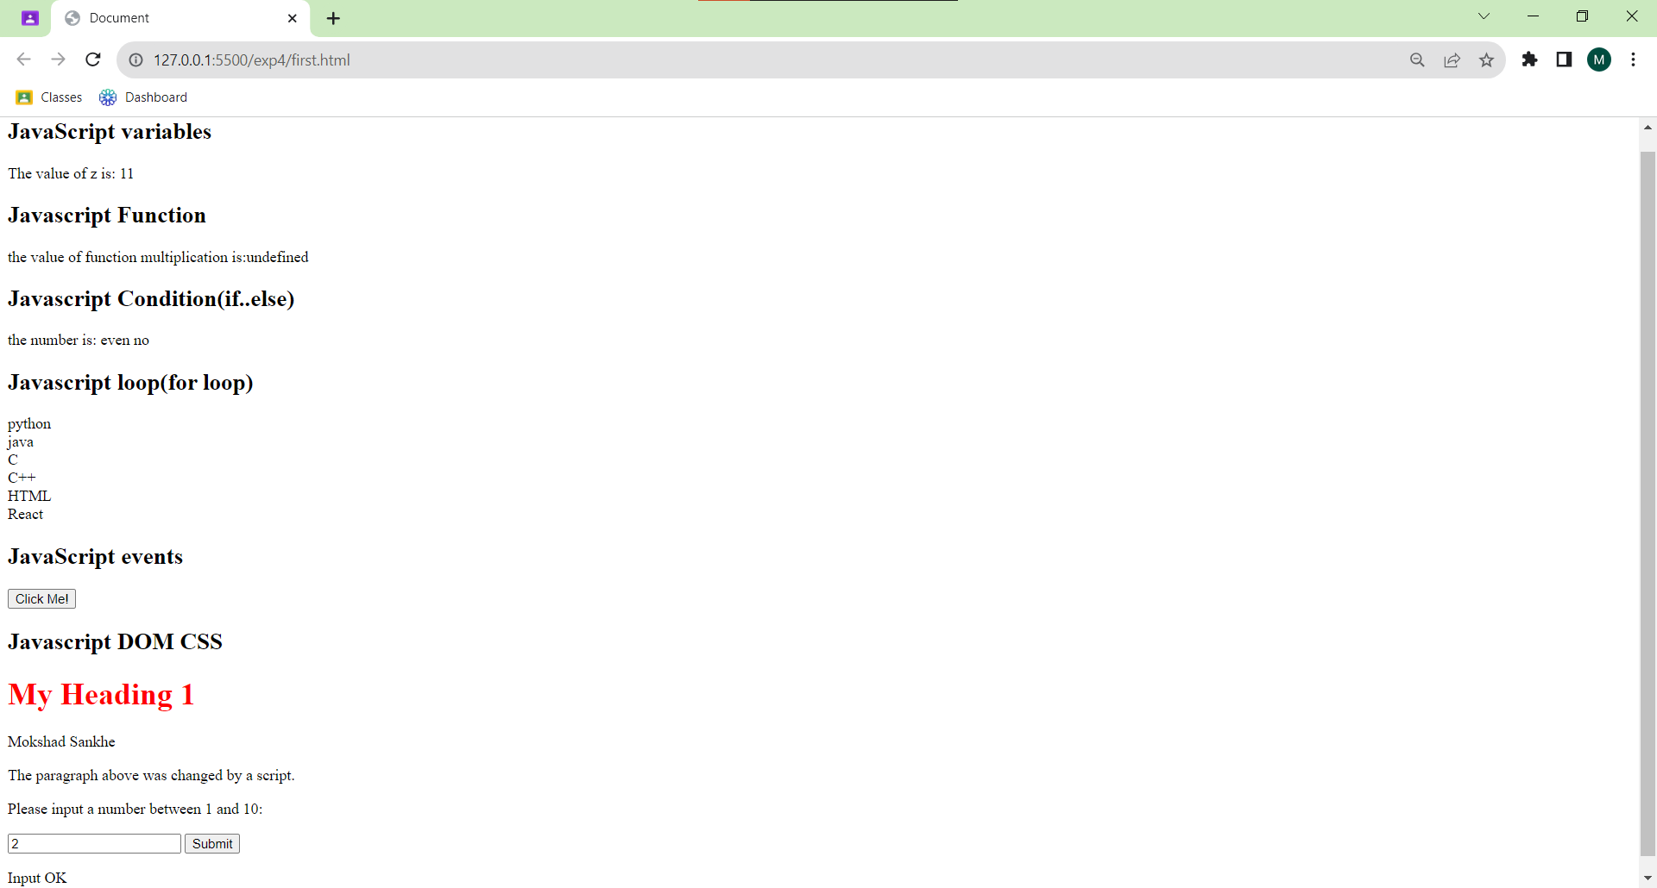

**Conclusion:**